Student Badges and Parking 2021-2022
OHSU Hillsboro Medical Center Education Building
Clinical Education Department
334 SE 8th Avenue, Hillsboro, OR 97123
Email: mkayla.stacy@tuality.org Phone: 503-681-1203
Student Badges: Students are required to wear their OHSU HMC issued identification badge at all times while on campus. Every patient has the right to know who is involved on their care team. Patients must be informed and provide verbal consent to having a student participate in their care.

Student ID Badges are property of HMC and are to be returned to the Clinical Education Department at the conclusion of the student’s clinical placement. While it is preferred that badges be returned to the Clinical Student Program Coordinator during business hours, this may not always be possible. Badges can be returned after hours to the 24hour drop box located at the front doors of the Education building.

For a lost or stolen ID badge, contact the OHSU, Hillsboro Medical Center Security Office immediately at 503-681-1082. Their office is open 24 hours a day, 7 days a week. The officer will deactivate your prior badge and a new badge will be issued. If your badge is left at home and you’re unable to retrieve it before your scheduled clinical, go to the security office near the ED entrance to request a temporary badge. Please bring your driver’s license or valid state identification and proof of your annual flu vaccination when attending Student Orientation or requesting a replacement or Temporary badge.

*For a clearer, more comprehensive map visit: THC 21479851 Heath and Education District Map vWEB (tuality.org)
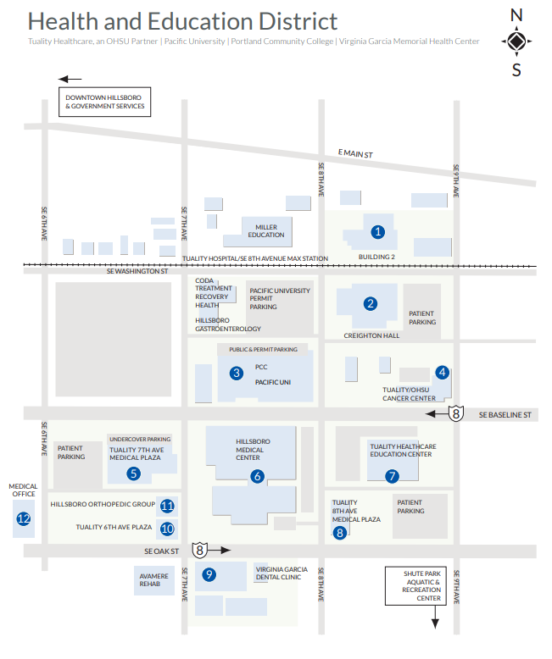 | Student Parking:  - Staff and students must park on levels 3 or 4 of either parking garage.  - Parking Garages are located at 9th and Oak St labeled “patient parking” or “ITF” #3 on map.  